ARTIVASC 3D SUMMER SCHOOL,
26-28.6.2013, Espoo, Finland

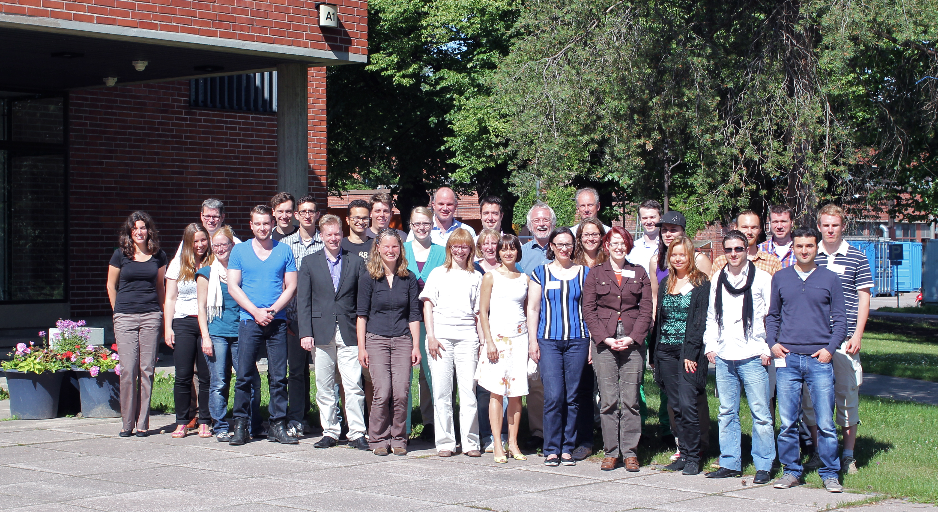
Starting in October 2011, 16 international partners from research and industry have been working together in the project ArtiVasc 3D. The objective is to develop a tiered technology for the generation of fully vascularised bioartificial tissue enabling nutrition and metabolism. The bioartificial skin engineered in ArtiVasc 3D will, for the first time, provide a 3-layered tissue replacement with fatty layer, dermis and epidermis. In the framework of the project a Summer School was held from 26th-28th of June, 2013 at Aalto University in Espoo, Finland.

The ArtiVasc 3D Summer School brought together 42 participants to encourage mutual training and exchange of knowledge and expertise in the field of bioartificial vascularised skin. Early career researchers, PhD students and post-docs, and five key-note speakers - experts from the field of medical applications, biomaterial (polymer) sciences and tissue engineering - gathered to share their expertise. The 3-day program covered five sessions: material, modeling and design, processing technologies, applied research and clinical perspectives. Hands-on lab work was also offered. Poster session, panel discussion and a social evening program complemented the Summer School.
Project Coordinator

Contact at Fraunhofer ILT

Dr. Arnold Gillner
Manager of Ablation and Joining expert group
Phone +49 241 8906-148
arnold.gillner@ilt.fraunhofer.de

Dipl.-Biol. Nadine Seiler
Biotechnology and Laser Therapy
Phone +49 241 8906-605
nadine.seiler@ilt.fraunhofer.de

Fraunhofer Institute for Laser Technology ILT
Steinbachstrasse 15
52074 Aachen
Phone +49 241 8906-0
Fax +49 241 8906-121
www.ilt.fraunhofer.de

70569 Stuttg
www.ilt.

